ASSIGNMENT 2

|  |  |
| --- | --- |
| **DATE** | **26 SEPTEMEBR 2022.** |
| **PROJECT NAME** | **AI based discourse for Banking Industry** |
| **NAME** | **Kamalesh S** |

1. Download the dataset: Dataset

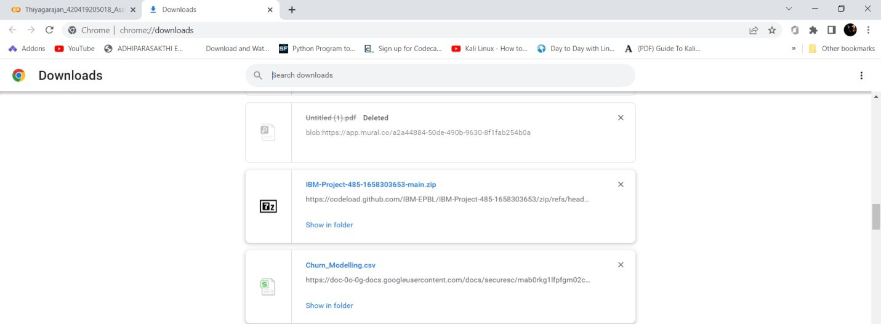

1. Load the dataset.

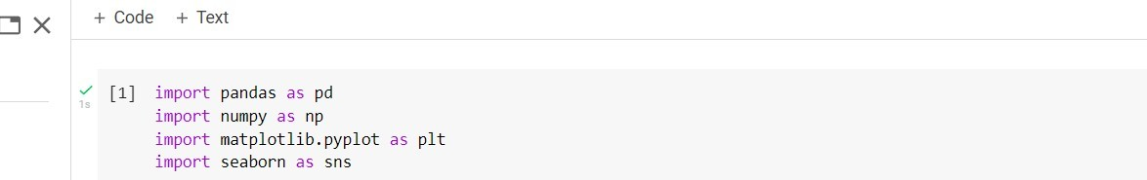

1. Perform Below Visualizations.

Univariate Analysis

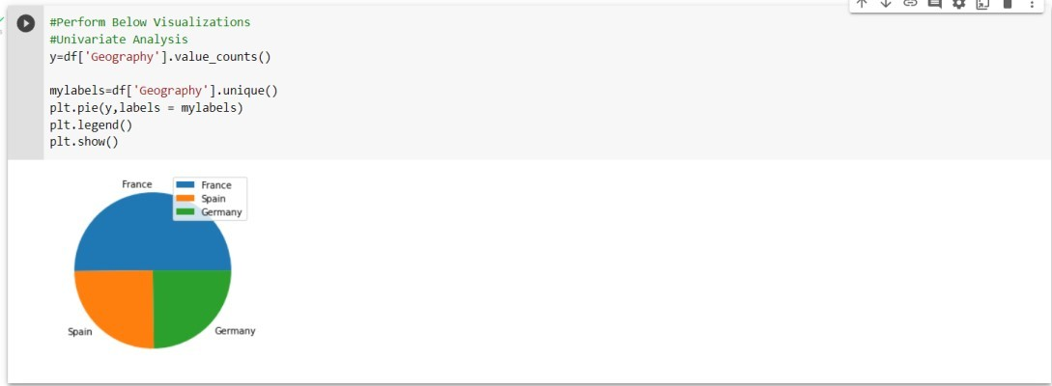

Bi - Variate Analysis

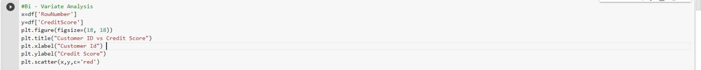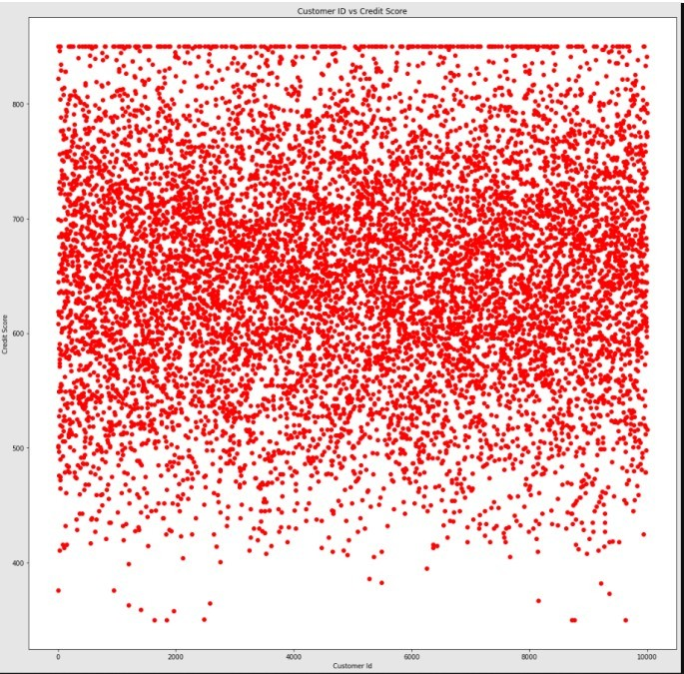

Multi - Variate Analysis

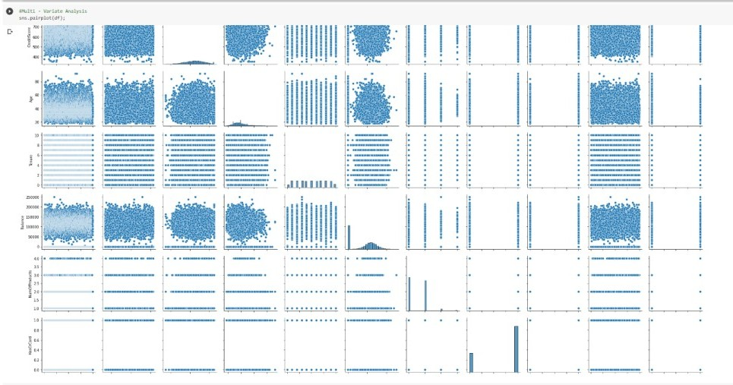

1. Perform descriptive statistics on the dataset.

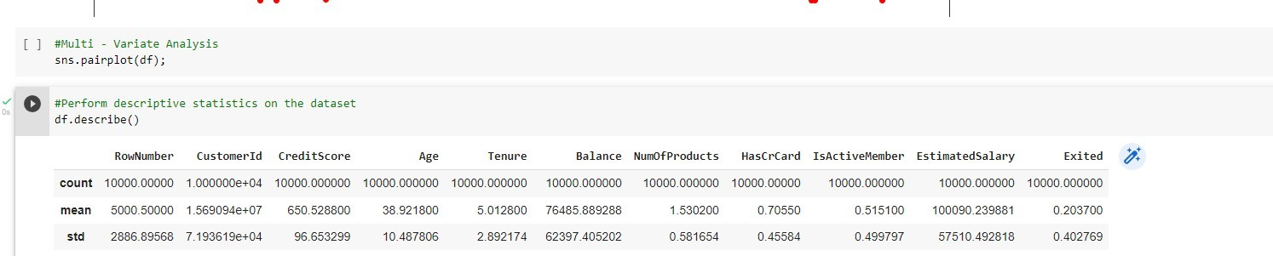

1. Handle the Missing values.

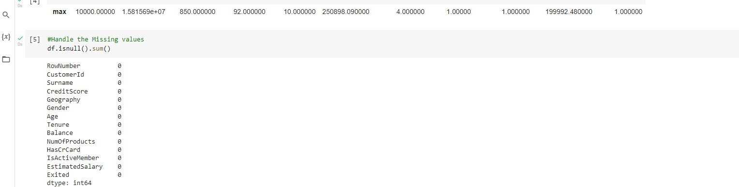

1. Find the outliers and replace the outliers

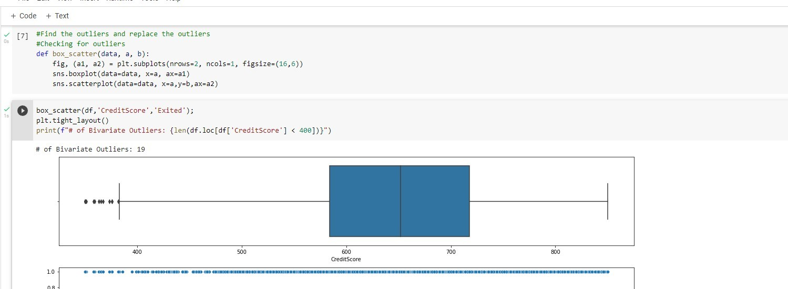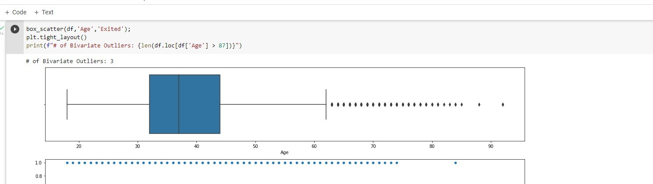

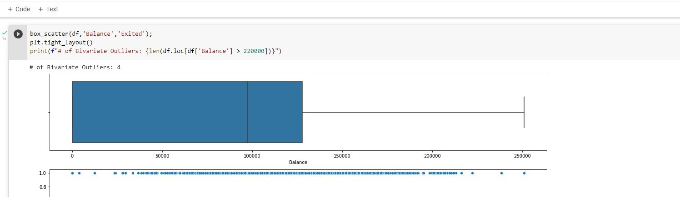

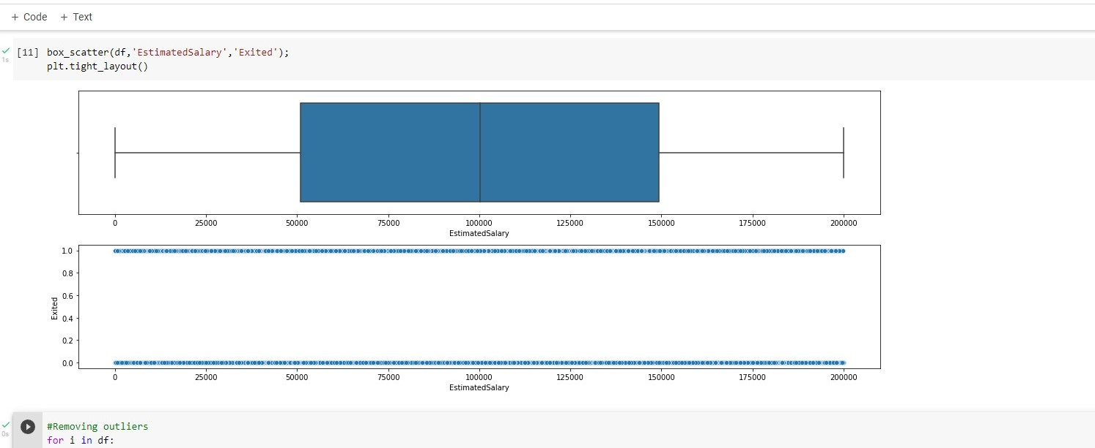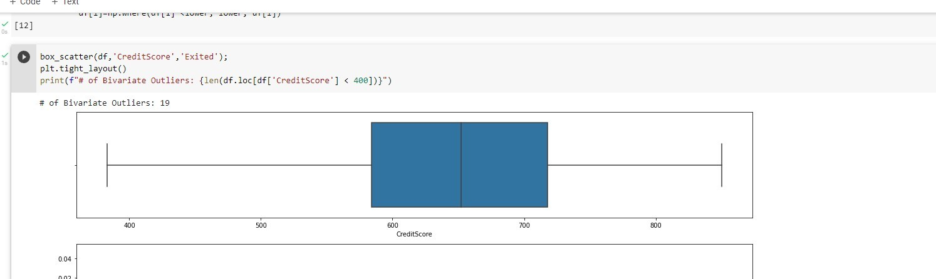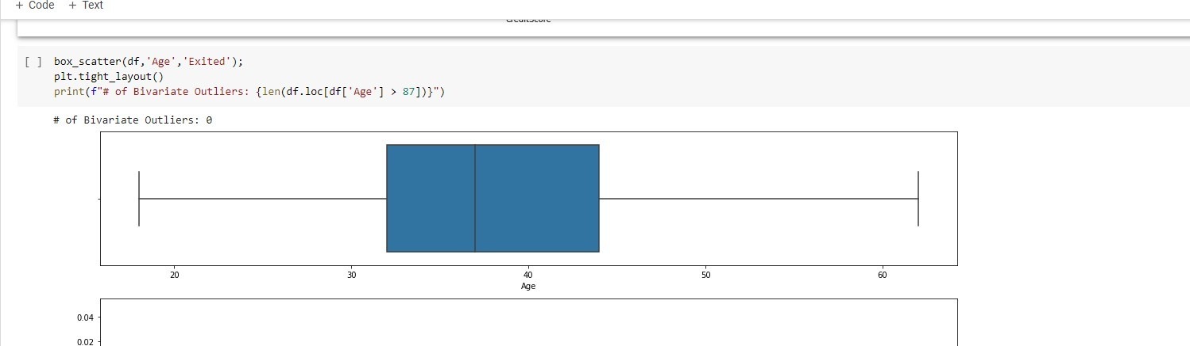

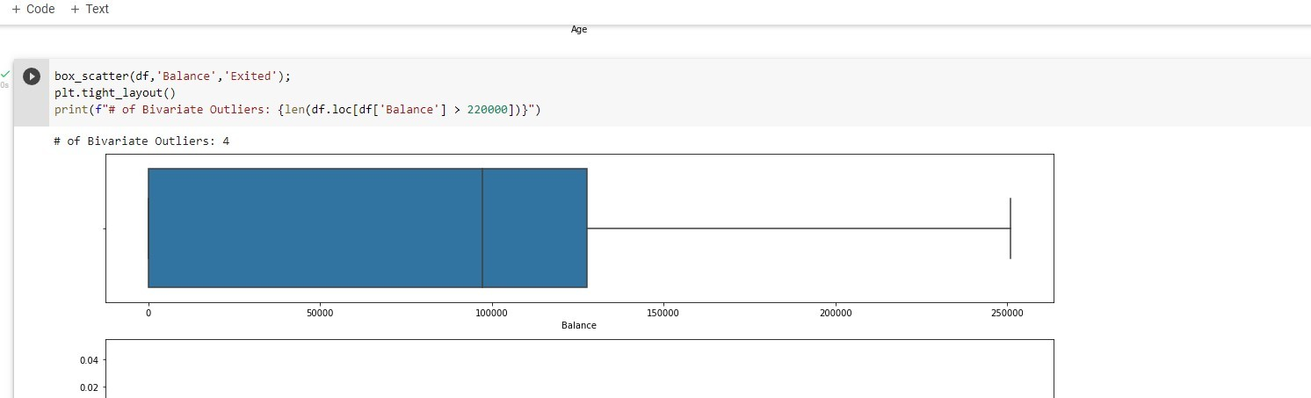

1. Check for Categorical columns and perform encoding.



1. Split the data into dependent and independent variables.



1. Scale the independent variables



1. Split the data into training and testing

